**The relationship of restaurant’s income and robbery rates**

HeeCheol Yu

07.26.2020

1. Introduction/Business problem

A restaurant is key service for people who want to live special or who do not have a time to make own meals. However, restaurants are threatened by some criminals. They can kill some innocence person or robbery shops, etc. To avoid those danger, this study is based on helping people planning to open a new restaurant in Toronto to choose the right location by providing data about the income and crime rate of each neighborhood for weighing safety and richness. There are many people in Toronto with high density. it is recommended to make their restaurant safe. In fact, safety cannot cover everything. Income is important too. Therefore, analyzing those two can make critical ways to solution.

1. Data

The data are from Toronto websites:

1. Toronto's 2016 Census([***https://www.toronto.ca/city-government/data-research-maps/open-data/open-data-catalogue/#8c732154-5012-9afe-d0cd-ba3ffc813d5a***](https://www.toronto.ca/city-government/data-research-maps/open-data/open-data-catalogue/#8c732154-5012-9afe-d0cd-ba3ffc813d5a)**)**
2. Toronto's 2016 crime rate([https://opendata.arcgis.com/datasets/af500b5abb7240399853b35a2362d0c0_0.csv?outSR=%7B%22latestWkid%22%3A26717%2C%22wkid%22%3A26717%7](https://opendata.arcgis.com/datasets/af500b5abb7240399853b35a2362d0c0_0.csv?outSR=%7B%22latestWkid%22%3A26717%2C%22wkid%22%3A26717%257))
3. Methodology

The data were analyzed by two factors: income of Toronto’s restaurants. To visualize well, they are combined to one table with geolocation data using folium and scatterplot using matplotlib.

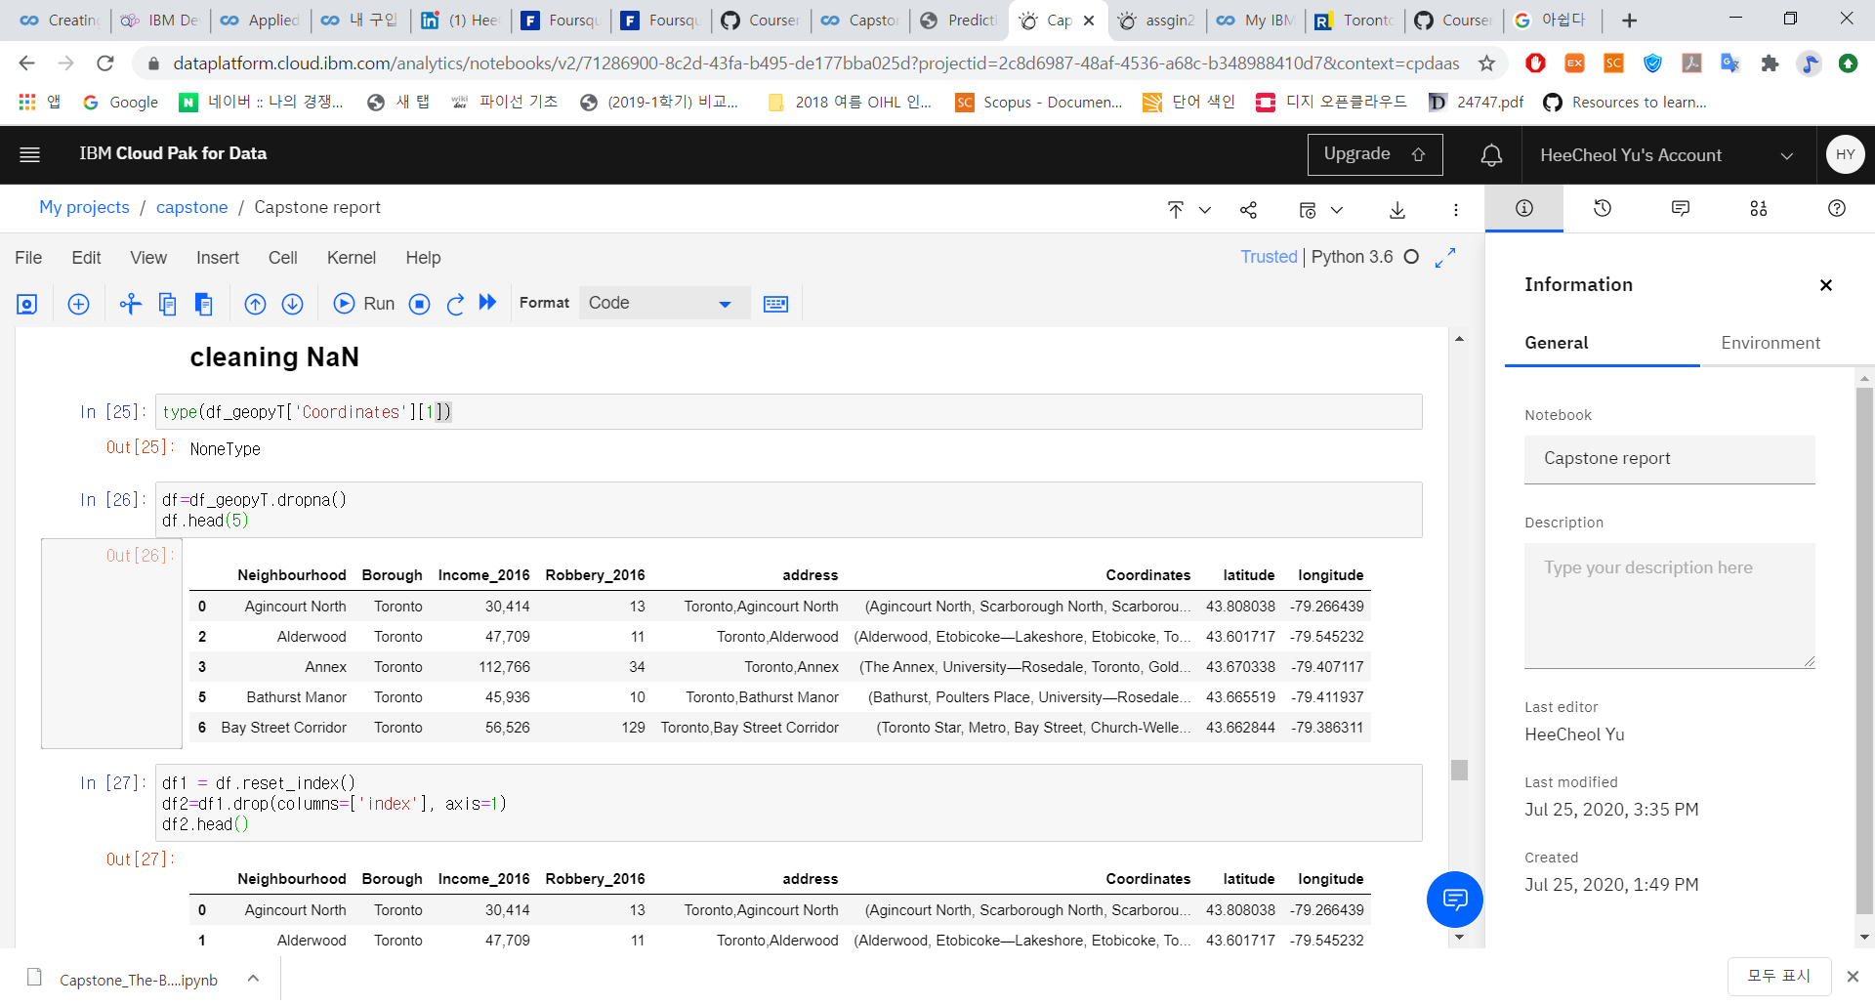

The table above is income and robbery data with geolocation data in each neighborhood. (neighbourhood is type-mistake)

1. Results

The figure below is a scatterplot of Income-Robbery data.

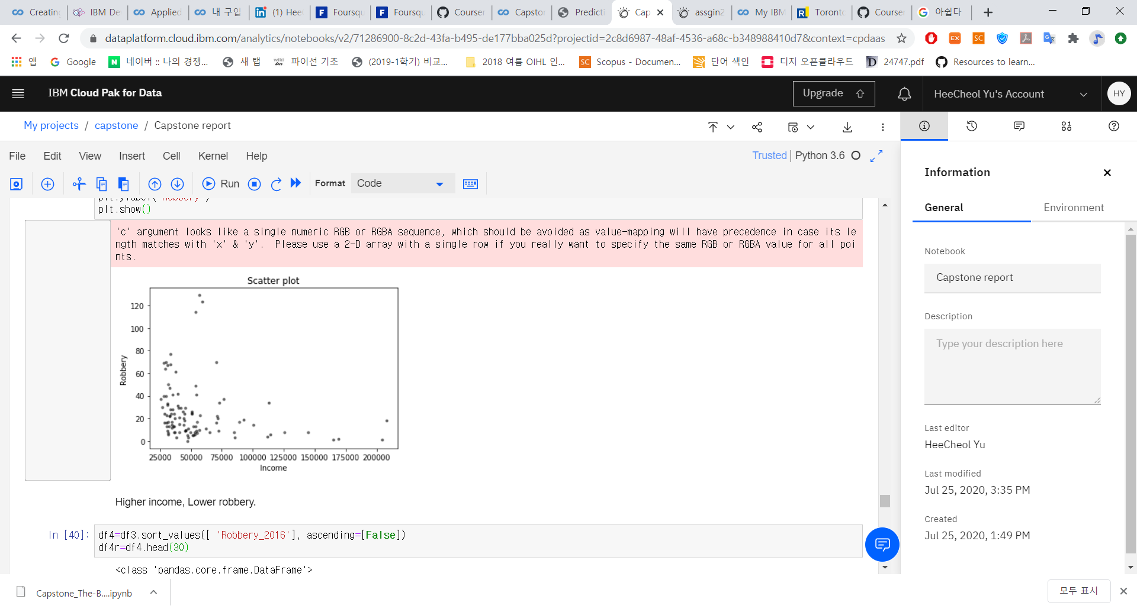

It shows a relationship of two factors. If a neighborhood has high income, low robbery is occurred.

The figure below is a folium map with markers.

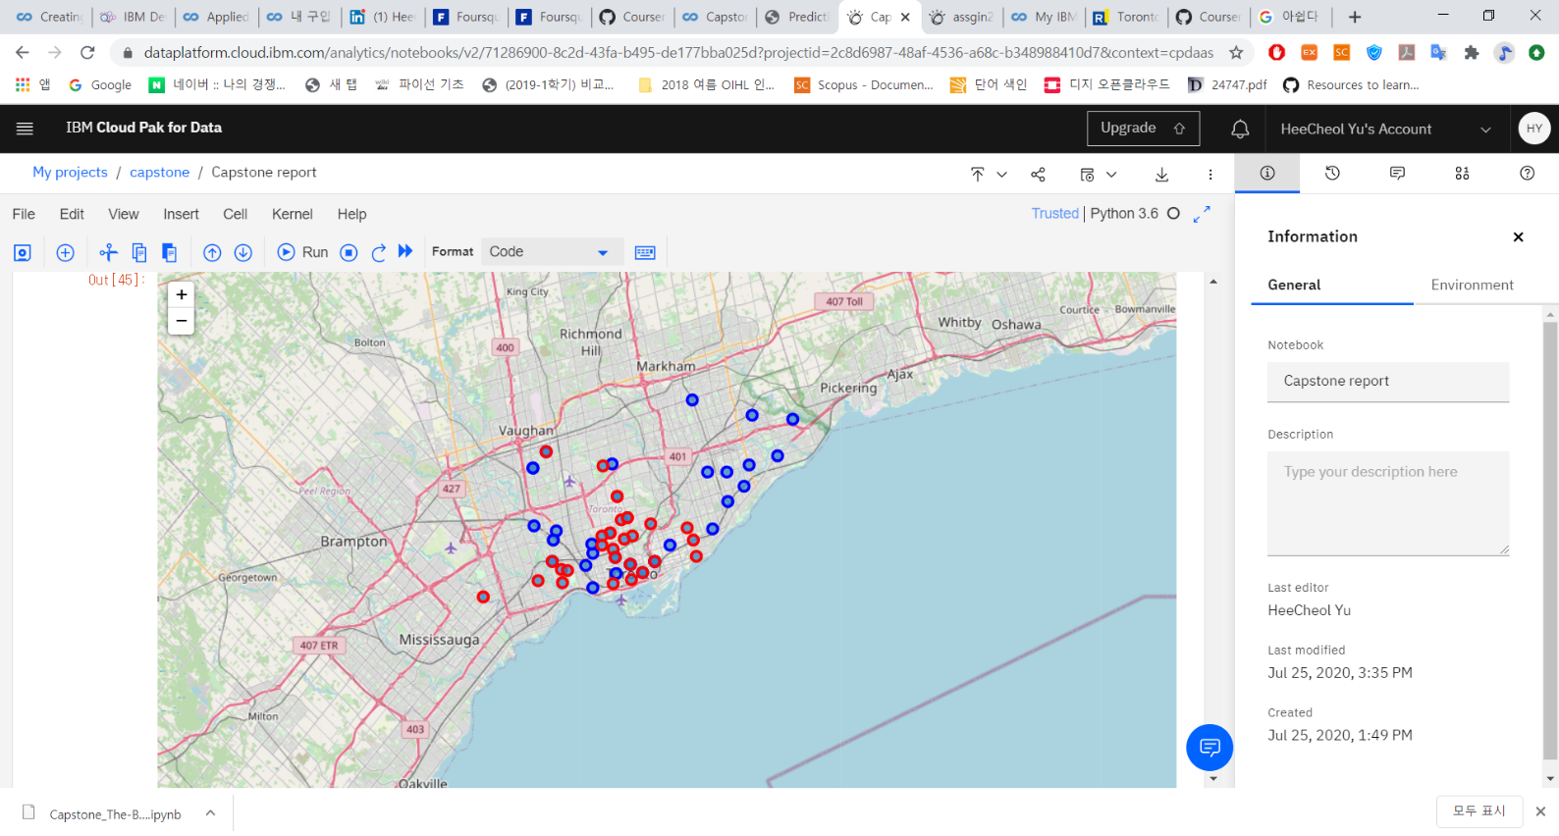

Blue dots are neighborhood where robbery occurred than 30 times. Red dots are neighborhood where income is more than 80000. It shows high income region does not overlap with high robbery region.

1. Discussion  
   Because it is hard to obtain json file, I just used folium and marker and a simple scatter plot. However, there is a significant finding in this report. There is a correlation about high income with low robbery rate. Also, those neighborhoods are clustered approximately by 3 group. To left to right, robbery zone, wealth zone, and robbery zone again. It is hard to cluster in my skills and not enough time. It is very bad. But I did my best to show their relationship.
2. Conclusion

Despite of this study's weakness about analyzing diverse, it shows meaningful relationship. According to data, if there are high income restaurant, they are safe than other neighborhoods. If our stakeholders are willing to open the restaurant, I will recommend those places. Safety is most important.